**LAB # 01**

**Task # 01:** Write a program that prints a mosque, similar to the following:

**Solution:**

public static void main(String[] args) {

System.out.println(" ^\t\t ^\t\t ^");

System.out.println(" |||\t\t |||\t\t |||");

System.out.println("((&)))\t\t.((^)).\t\t((&)))");

System.out.println(" |.|\t (((((^)))))\t |.|");

System.out.println(" |.|\t ((((((^))))))\t |.|");

System.out.println(" {'''''''''''''''''''''''''''''''''}");

System.out.println("'|'''''''''''''''''''''''''''''''''|'");

System.out.println(" | _ |");

System.out.println(" | _{#}_ |");

System.out.println(" | {#####} |");

System.out.println(" | _____ {#######} ______ |");

System.out.println(" ||#####| {#########} |######| |");

System.out.println(" ||#####| {#########} |######| |");

System.out.println(" |======= {#########} ======== |");

System.out.println(" | {#########} |");

System.out.println(" | {#########} |");

System.out.println(" |@@@@@@@@@@@=========@@@@@@@@@@@@@|");

System.out.println(" |++++++++++/=========+++++++++++++|");

System.out.println(" |%%%%%%%%%%/=========%%%%%%%%%%%%%|");

System.out.println(" |''''''''''/========='''''''''''''|"); }

**Output:**

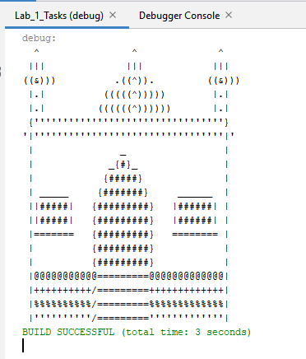

**Task # 02:**  Write a JAVA program, which receives the input of two integer numbers, operation (+,-

,*,/,%, power, square-root and factorial) and compute arthematic operations. Generate a menu for operations and ask user after every operation if they want to do another. (Hint use switch case)

**Solution:**

public static void main(String[] args) {

Scanner input = new Scanner(System.in);

System.out.println("Enter which funstion which you want use: \n 1 for Adiidtion \n 2 for Substraction \n 3 for Multiplication \n 4 for Divisaion \n 5 for Modulus \n 6 for Power \n 7 for Square \n 8 for Factorial: ");

int ans = input.nextInt();

char again ;

do{

switch(ans){

case 1:

System.out.println("Enter num 1");

int num1 = input.nextInt();

System.out.println("Enter num 2");

int num2 = input.nextInt();

int num3 = num1+ num2;

System.out.println("The answer is : "+ num3);

break;

case 2:

System.out.println("Enter num 1");

int a = input.nextInt();

System.out.println("Enter num 2");

int b = input.nextInt();

int c = a - b;

System.out.println("The answer is : "+ b);

break;

case 3:

System.out.println("Enter num 1");

int n1 = input.nextInt();

System.out.println("Enter num 2");

int n2 = input.nextInt();

int n3 = n1 * n2;

System.out.println("The answer is : "+ n3);

break;

case 4:

System.out.println("Enter num 1");

int x = input.nextInt();

System.out.println("Enter num 2");

int y = input.nextInt();

int z = x/y;

System.out.println("The answer is : "+ z);

break;

case 5:

System.out.println("Enter num 1");

int d = input.nextInt();

System.out.println("Enter num 2");

int e = input.nextInt();

int f = d % e;

System.out.println("The answer is : "+ f);

break;

case 6:

System.out.println("Enter number");

int number = input.nextInt();

System.out.println("Enter Power");

int power = input.nextInt();

int answer = (int) Math.pow(number, power);

System.out.println("The answer is : "+ answer);

break;

case 7:

System.out.println("Enter number");

int sq = input.nextInt();

int square = sq*sq;

System.out.println("The answer is : "+ square);

break;

case 8:

int result=0;

System.out.println("Enter num");

int get = input.nextInt();

for (int i=1; i <= get; i++){

result = get*(get-1);

}

System.out.println("The answer is : "+ result);

break;

default:

System.out.println("Invald Entry");

break;}

System.out.println("Do you want agian ? ");

again = input.next().charAt(0);

}while(again == 'y');}

**Output:**

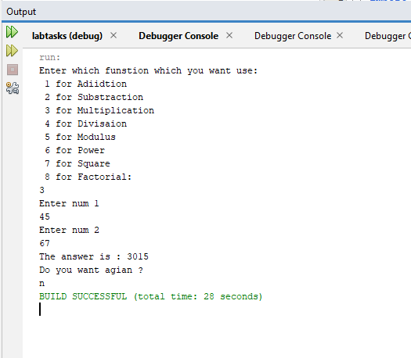

**Task # 03:** Make a program in JAVA in which take no. of items, price of items and name of items as input from the user and give the discount according to the following conditions:

1. If from Bahria University give discount of 30%.
2. Else if the total amount is greater then 50,000 and less than 100,000 give discount of 20%.

Else if the total amount is greater then 100,000 give discount of 30%.

**Solution:**

public static void main(String[] args) {

// TODO code application logic here

// System.out.println("hello world");

Scanner input=new Scanner(System.in);

int no,price,t=0;

String nam;

double T=0,tot=0;

System.out.println("Enter Number of item: ");

no= input.nextInt();

for (int i = 1; i <= no; i++) {

System.out.println("Enter Name of Item "+i);

nam=input.next();

System.out.println("Enter price of item "+nam);

price=input.nextInt();

t=price+t;}

System.out.println("Are You From Bahria University 1) yes 2)no");

int ans=input.nextInt();

if (ans==1) {

T=t*0.30;

tot=t-T;}

else if(ans==2 & t>=50000 & t<=100000){

T=t*0.20;

tot=t-T;

}

else if(t>100000){

T=t*0.30;

tot=t-T;}

System.out.println("*********************");

System.out.println("Total Bill= "+t);

System.out.println("discount Price= "+T);

System.out.println("Total Bill after discount = "+tot);

System.out.println("***********************"); }

**Output:**

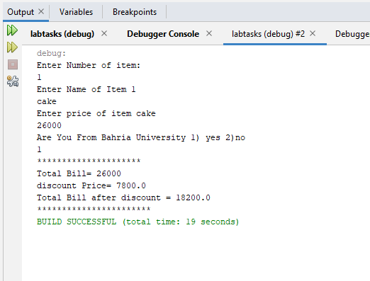

**Task # 04:** Write a JAVA program which will implement the following formulae using methids.

1. Automobile Tire Pressure: P = 0.37m(T + 460)/V P = pressure in psi.

V = volume in cubic feet

m = mass of air in pounds

T = temperature in Fahrenheit

1. Pulley formulas
   1. calculate the speed of one pulley if there are 2 pulleys connected with a belt:

RPM2 = diameter1/diameter2 * RPM1

* 1. calculate the amount of weight that can be lifted with a multiple pulley system:

weight lifted = force exerted * number of up ropes

1. The body mass index (BMI), is a heuristic proxy for human body fat based on an individual's weight and height. BMI does not actually measure the percentage of body fat. We will be building a BMI calculator method. Body mass index (BMI) is computed using the the formula,



Where mass is the subject's weight in pounds (lb) and height is the height in inches (in). The value 703 is a factor to convert BMI to a value that matches the original BMI calculations done in metric units (i.e. kilograms-meters).

**Solution:** public class JavaApplication4 {

Scanner read = new Scanner(System.in);

void Pressure() {

double pressure, volumn, temperature, mass;

System.out.print("Enter Volumn in Cubic Meter : ");

volumn = read.nextDouble();

System.out.print("Enter Mass Of Air In Pound : ");

mass = read.nextDouble();

System.out.print("Enter Temperature In Fahrenhiet : ");

temperature = read.nextDouble();

pressure = (0.32 * mass * (temperature + 460)) / volumn;

System.out.println("----------------------------------------------------");

System.out.println("Automobile Tire Pressure IS " + pressure);

} void Pully() {

double RPM1, dia1, dia2, RPM2;

System.out.print("Enter The Speed Of 1st Pully : ");

RPM1 = read.nextDouble();

System.out.println("--------------Calculate The Speed For 2nd Pully-----------");

System.out.print("Enter The Diameter 1 : ");

dia1 = read.nextDouble();

System.out.print("Enter The Diameter 2 : ");

dia2 = read.nextDouble();

RPM2 = (dia1 / dia2) * RPM1;

System.out.println("--------------------------------------------------------");

System.out.println("The Speed OF 2nd Pully IS " + RPM2);

} void Weight() {

System.out.println("Calculate the Amount of Weight that Can be Lifted With a Multiple Pulley System");

double weight, force, number;

System.out.print("Enter The Force Exerted On Pully : ");

force = read.nextDouble();

System.out.print("Enter The Number Of Up Ropes : ");

number = read.nextDouble();

weight = force * number;

System.out.println("----------------------------------------------------");

System.out.println("Weight Lifted Of Pully Is " + weight);

} void BMI() {

double BMI, mass, height;

int a = 703;

System.out.println("Enter Mass in pounds (lb) : ");

mass = read.nextDouble();

System.out.println("Enter Height In Inches (In) : ");

height = read.nextDouble();

BMI = (mass / (height * height)) * a;

System.out.println("----------------------------------------------------");

System.out.println("The Body Mass Index (BMI) Is " + BMI);

}

public static void main(String[] args) {

Scanner sc = new Scanner(System.in);

JavaApplication4 obj = new JavaApplication4();

int res;

char res1;

do{

System.out.println(" 1) Pressure ");

System.out.println(" 2) Pully Speed ");

System.out.println(" 3) Pully Weight");

System.out.println(" 4) BMI Calculate");

System.out.println("Select from above: ");

System.out.print("Enter your choice : ");

res=sc.nextInt();

switch(res){

case 1:

obj.Pressure(); break;

case 2:

obj.Pully(); break;

case 3:

obj.Weight(); break;

case 4: obj.BMI();

break;}

System.out.println(" If you Want To Calculate Again select (y/n)");

System.out.print("Enter : ");

res1=sc.next().charAt(0);

}while(res1=='y'||res1=='Y'); }

**Output:**

